SQL Answers - Task 1

1) How much is each member borrowing?
I put a screen shot of the answer because the answer was too long to write
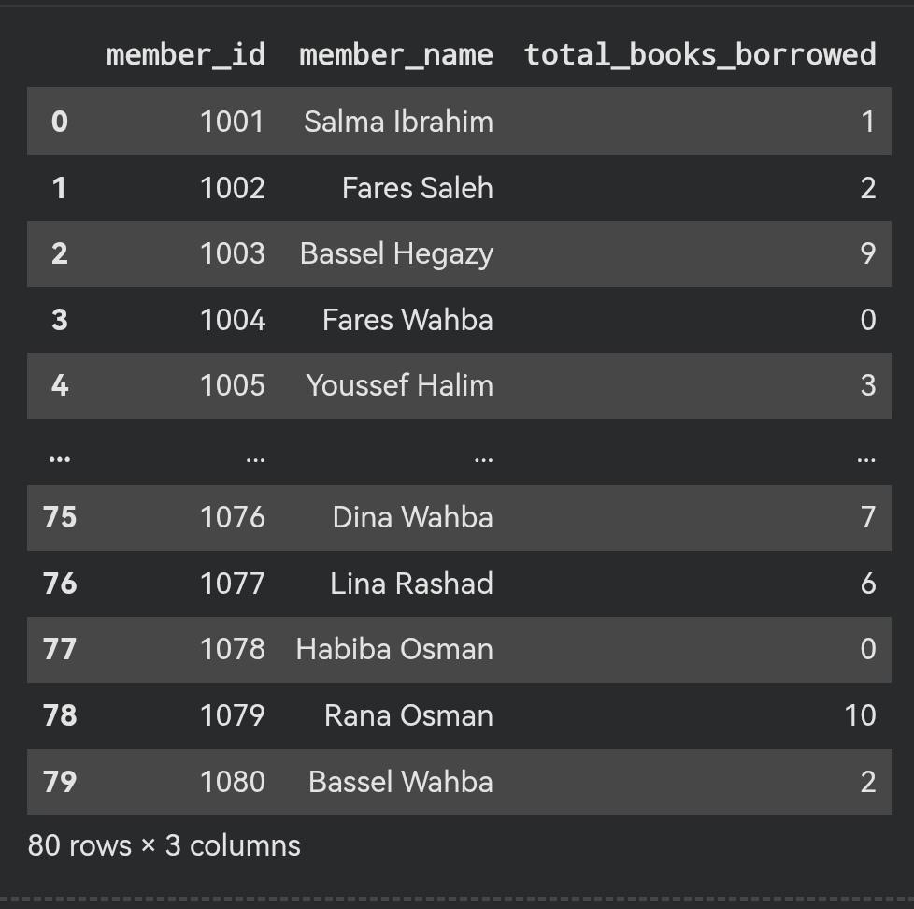

2) Which books match a chosen author pattern?
I chose the pattern of authors whose names start with the letter A.
1-Amina Darwish
2- Adel Roushdy
3-Aya Hafez
3) What are the most popular books?
The most popular books are 1- the silver kite
2- fossils and fireflies
3- circuits for beginners
4- kites over cairo
5- storms and sailboats
4) Who are the most active readers?
The most active readers are 1-Aya Wahba 2-Sherif Saleh 3-Ziad Saleh
4-Nour Nabil 5-Mostafa Fouad
6-Youssef Hegazy 7-Ahmed Shafik
8-Adam Fahmy 9-Sara Rashad 10-Reem Osama
5) What does a neighborhood's activity look like further back in time?
In heliopolis in 2024 the total books was 41 book
In el maadi in 2024 the total books was 49 book
In nasr city in 2024 the total books was 31 book
In shubra in 2024 the total books was 19 book
In el zamalek in 2024 the total books was 33 book
In heliopolis in 2025 the total books was 45 book
In el maadi in 2025 the total books was 58 book
In nasr city in 2025 the total books was 69 book
In shubra in 2025 the total books was 15 book
In el zamalek in 2025 the total books was 31 book

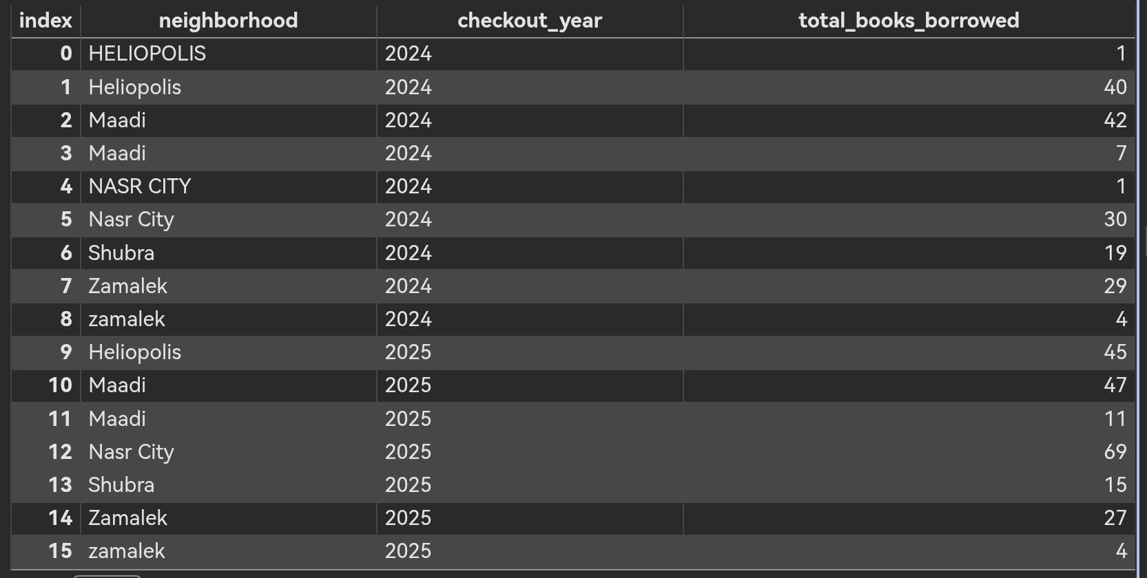
Some screen shots to prove my answers